[INSERT ORGANIZATION NAME] now offers the only personalized, adaptive language-learning experience that provides the tools and guidance you need to expand your language skills wherever and however you learn best. Here’s why that’s awesome:

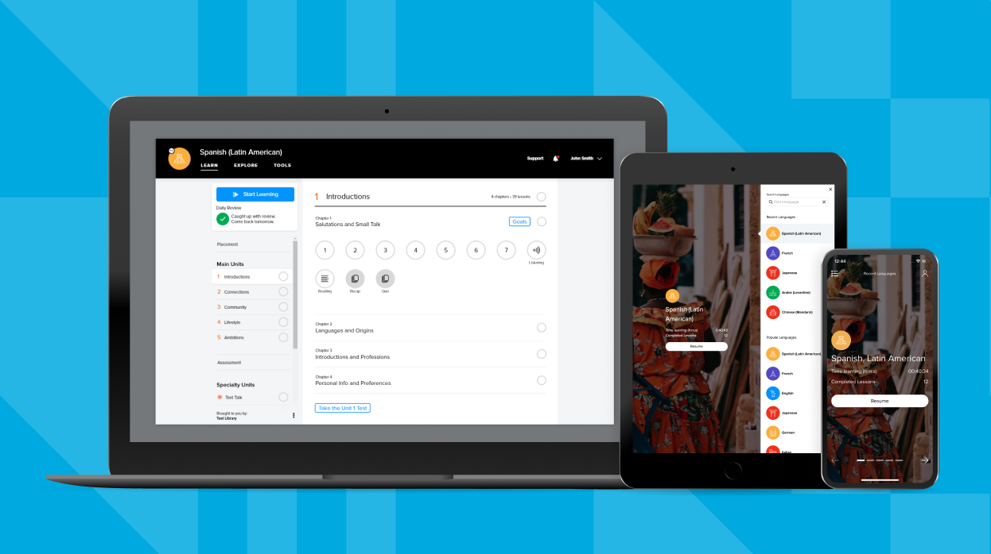
Our favorite Mango features include: | - Real-world conversations that won’t leave you lost in translation  - Voice Comparison for matching your pronunciation with native-speaker audio  - Listening & Reading Activities for reinforcing learned material and building new skills  - Personalized Review System that adapts to your individual learning pathway  - Culture Notes for unique insights into different cultures  - Mango Movies for learning through engaging, authentic content
Download the free Mango app from the App Store or Play Store, open up a new browser from your desktop and use the info below to begin: [LOGIN INSTRUCTIONS]

